Grand View Garden Hotel
88 Nancaiyuan Street
Xuanwu District
Beijing 100054
China
Tel (010) 63268899/63538899
Fax (010) 63539189
Guestroom Facilities

- Individually-controlled air-conditioning
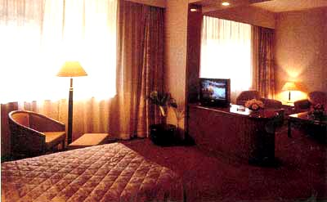
Standard suite
- International satellite TV with remote control
- IDD and DDD telephone lines
- Hairdryer
- Make-up mirror and bathrobe
- In-room safe and minibar
- Electricity water pot in some rooms
- Non-smoking floor
- Electricity:110/220volts
- Same-day laundry and cleaning service
- Business center
- Ticket and travel service
- Baby-sitting service
- Limousine and bike rental service
- Medical clinic
- Money exchangs service
- Beauty salon
- Shopping arcade
- Shoe shine service
- Car park
- Luggage storeroom

